Ideation Phase
Define the Problem Statements

Date | 20 Feb 2026
Team ID | LTVIP2026TMIDS79198
Project Name | Resolve Now – Online Complaint Registry Platform
Maximum Marks | 2 Marks

Project Overview
The Complaint Registry is a web-based application developed to simplify the process of registering, tracking, and resolving public or organizational complaints digitally. Many people face difficulties when submitting complaints through traditional offline methods such as visiting offices, filling manual forms, or waiting for responses without updates.
This system provides a centralized platform where users can submit complaints online, track their status, and receive updates, while administrators can manage and resolve issues efficiently. The goal is to improve transparency, accountability, and communication between users and authorities.
Reference: https://miro.com/templates/customer-problem-statement/

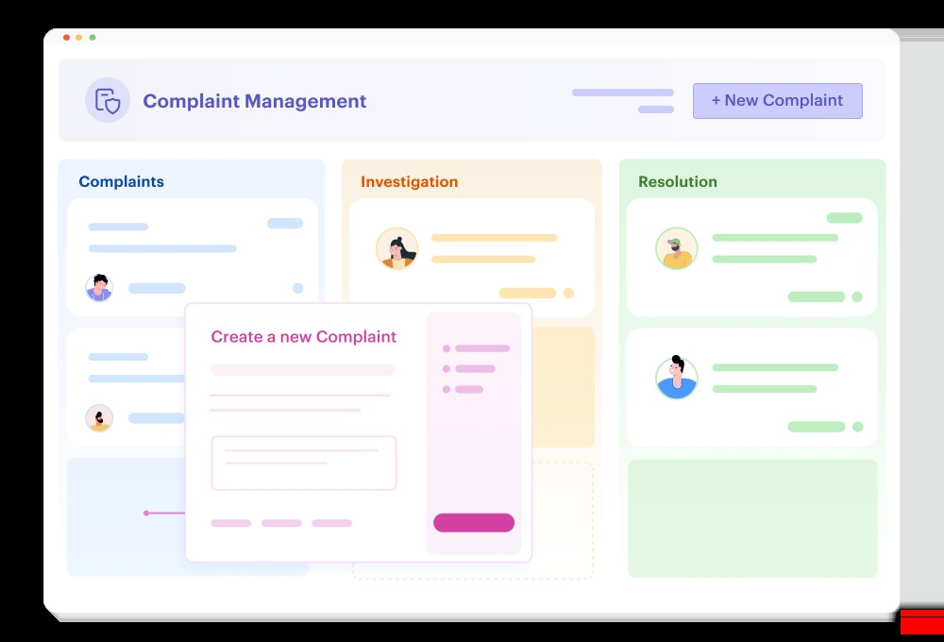

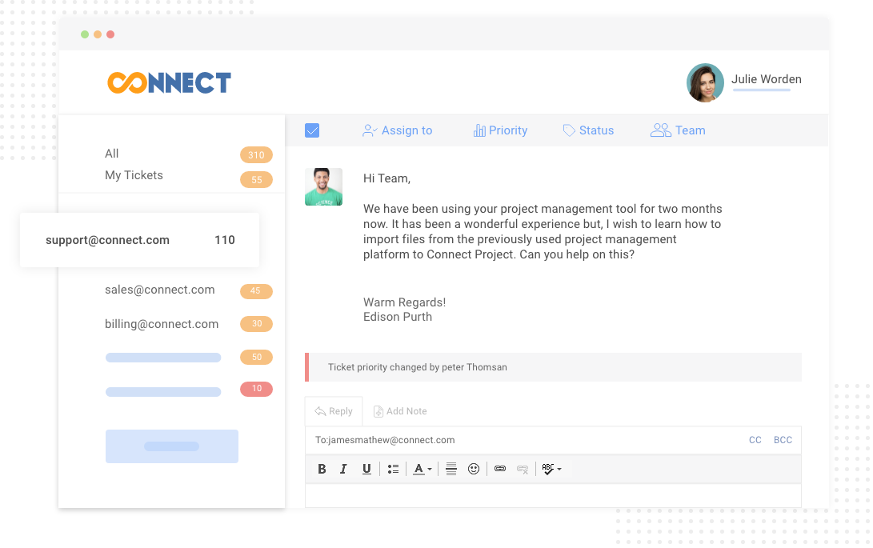
Problem Background
In many organizations and public service systems, complaint handling is still manual or poorly organized. Users often do not know where to complain or how long resolution will take. Complaints may get lost, delayed, or ignored due to lack of tracking systems. Citizens and customers need a simple digital platform where complaints can be registered easily and monitored transparently. Without such systems, communication gaps occur between service providers and users, leading to dissatisfaction and inefficiency.
The Complaint Registry project addresses these issues by providing an organized complaint submission and management system that ensures every complaint is recorded and tracked until resolution.
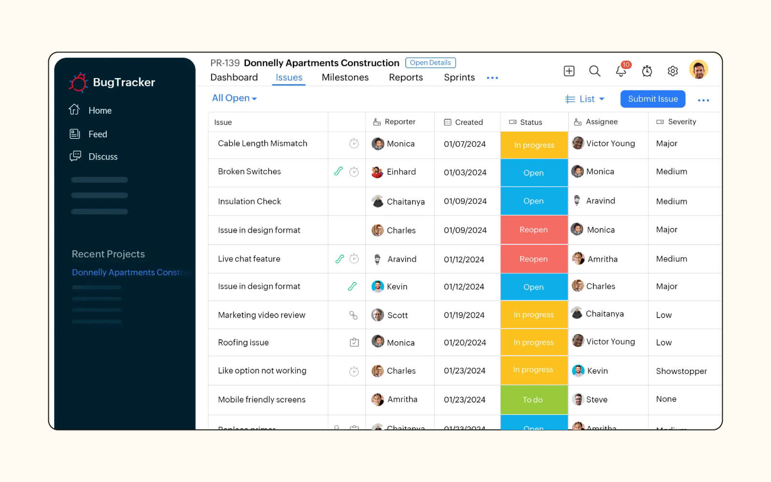

Proposed Solution
The Complaint Registry system provides a digital solution where:
- Users can register complaints online.
- Complaints are stored securely in a database.
- Admins can review and update complaint status.
- Users receive transparent updates.
- Complaint resolution becomes faster and organized.
This system improves efficiency, reduces paperwork, and enhances user satisfaction by creating a reliable communication channel between users and administrators.
Expected Outcomes
- Faster complaint resolution
- Increased transparency
- Digital record maintenance
- Improved user satisfaction
- Efficient administrative management

